Predicting Personal Income from Demographic and Employment Factors using Multiple Linear Regression

Oko Alexander Kenechukwu & Nick Adams

Math 4373, Regression Analysis with Dr. Janet Nakarmi
April 29, 2026
Colab

Abstract
This report covers how Personal Income is influenced by a combination of demographic, educational, and employment related factors. We used multiple linear regression to model and explain personal income using age, sex, race, education level, weekly work hours, and person-weight as predictors. Because personal income was skewed, we transformed the response variable using the log of income (lny), to improve the model fit and help variance. The final model included categorical predictors, continuous predictors, and interaction terms such as age by weekly work hours, age by sex, and weekly work hours by education level. The model explained approximately 40.8% of the variation in log income. Diagnostic checks showed that linearity and independence were reasonably satisfied, while normality, equal variance and multicollinearity were not ideally met. These findings suggest that education and labor related variables are the strongest practical predictors of income, but the results should be interpreted as associations rather than causal effects. Overall, the model provides useful information and insight into how income varies across demographic and employment groups, but individual coefficient interpretations should be made carefully due to the remaining assumption concerns.

Introduction
In general, our interests lie in answering the question: What factors influence income levels, and how can these factors be used to accurately predict earnings?
Understanding and predicting this outcome is meaningful in the real world. It benefits lawmakers- who can decide which job/industry needs subsidies, it benefits employees- who can gauge how their personal characteristics fare in the job market, it benefits employers- who can determine market price for labor. The dataset in this study is drawn from the American Community Survey (ACS), which collects demographic, social, and economic information. It contains roughly 1.7million observations. As mentioned earlier, the variables are as follows:
- Response Variable (Y): PINCP- Personal Income
- Candidate Predictors: Person weight (PWGTP), Sex (SEX), Race (RAC1P), Education level (SCHL), Age (AGEP), Weekly work hours (WKHP)
The primary goal is to build an interpretable Multiple Linear Regression model, perform variable selection, validate regression assumptions, and draw statistical inferences about the population.

Methodology

Exploratory Data Analysis (EDA)
  - Univariate Analysis: Histograms or density plots for the response variable and continuous predictors to check for severe skewness.
  - 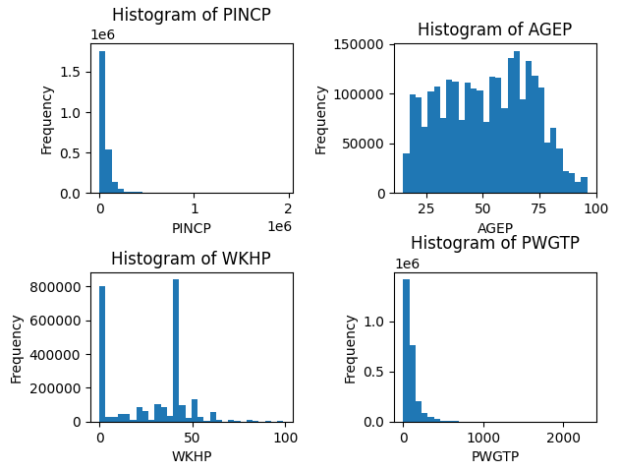
  - Bivariate Analysis: Scatterplots (Predictors vs. Response) to visually assess initial linear relationships
  - 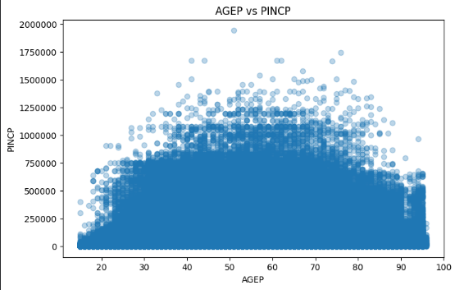
  - 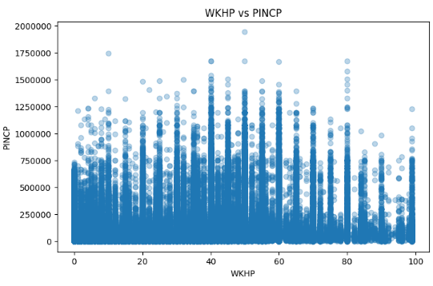
  - 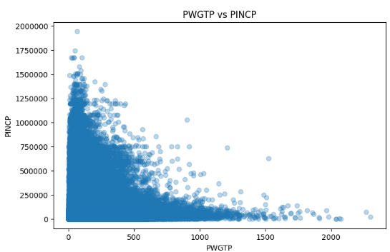

  - Correlation Matrix: Generate a correlation heatmap for all continuous variables to identify potential multicollinearity early on.
  - 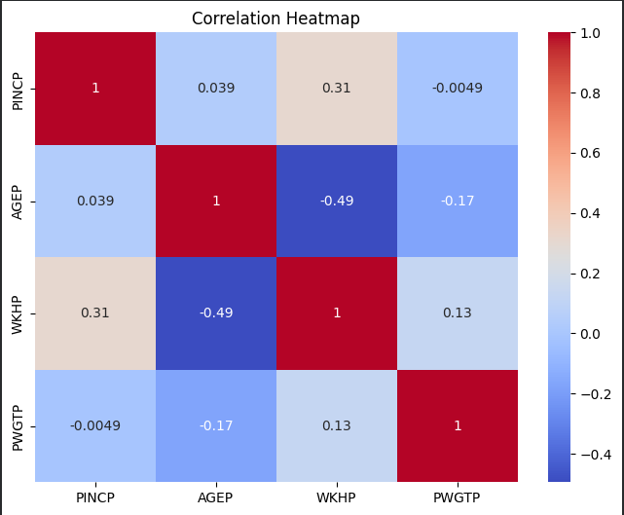
  - Categorical Variables: Boxplots of the response variable split by categorical groups.
  - 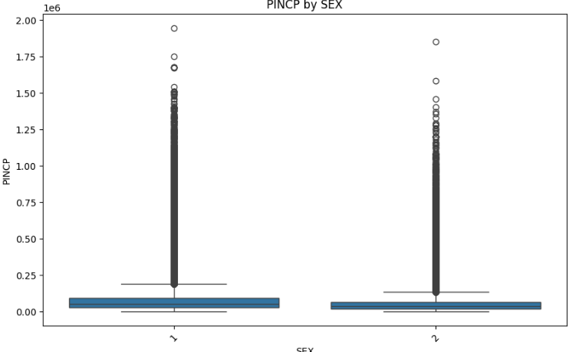
  - 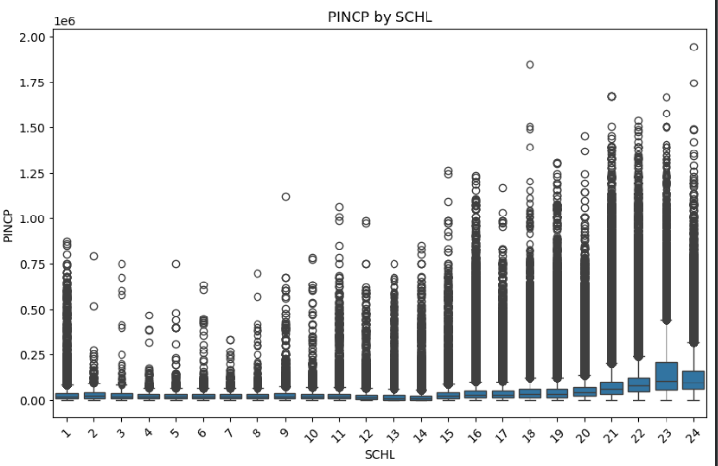
External Code: includes comments on nearly every line also inside colab
.dropna() removes any missing values and bins=30 just creates more bars on the chart rather than the standard. This just allows us to see more details.
plt.hist(income_df[col].dropna(), bins=30)

Creates a scatter plot between one predictor and the response variable. Each loop the col changes such as being either AGEP, WKHP, or PWGTP, uses alpha=0.3 to change transparency of the dots. With this many points being scattered, without this it kind of looks a mess. Just helps it to be easier on the eyes.
plt.scatter(income_df[col], income_df[response_var], alpha=0.3)

Rotated the category labels because the boxcox PINCP vs RAC1P labels overlapped and were unreadable. This just makes all of the labels a little cleaner also.
plt.xticks(rotation=45)

.nobs gets the number of observations used in fitting the model, and later the variable n is used in formulas for things like cooks distance or leverage.
n = int(income_lm.nobs)

This creates a list of evenly spaced row indexes starting at the beginning and going to the end. In our case, MAX_ROWS = 10000, so this creates 10000 row indexes spread across the entire dataset used, which is over a million data points. Plotting over a million points just isnt feasible for this, so this is a way to still pull data from start, middle, end. I also attached output so you can see at a glance.
idx = np.linspace(0, n - 1, MAX_ROWS, dtype=int)


Data Preprocessing
This process is as follows:
1. Removal of Irrelevant Columns
The dataset initially contained at least one column with no recorded values. Such columns provide no analytical value and can interfere with processing, so all columns containing entirely missing values were removed. This step reduces dimensionality and improves computational efficiency.
2. Selection of Relevant Variables
Only the variables necessary for analysis were retained:
- Person weight (PWGTP)
- Sex (SEX)
- Race (RAC1P)
- Education level (SCHL)
- Personal income (PINCP)
- Age (AGEP)
- Weekly work hours (WKHP)
This step ensures that the dataset remains focused on meaningful predictors and avoids unnecessary complexity in later modeling stages. The process of picking these variables was manual, for simplicity and to capture extremely important predictors.
3. Data Type Standardization
All variables were explicitly converted to numeric data types. Any non-numeric entries or corrupted values were coerced into missing values (NaN). This guarantees consistency across the dataset and prevents errors in downstream analyses.
4. Handling Missing Values
Rows containing missing values in any of the selected variables were removed. Since the analysis relies on complete observations for all predictors and the response variable, eliminating incomplete records ensures reliability and avoids bias introduced by imputation.
5. Validation and Filtering of Data
To maintain data integrity, several constraints were applied based on realistic and dataset-specific ranges:
- SEX was restricted to valid coded values (1 = Male, 2 = Female).
- AGEP (Age) was limited to values between 0 and 100.
- SCHL (Education) and RAC1P were mapped to a dictionary.
- WKHP (Work hours per week) was constrained between 0 and 99, consistent with survey coding standards.
- PWGTP (Person weight) was required to be strictly positive.
These filters remove outliers, data entry errors, and invalid responses, ensuring that only meaningful observations remain. It also defines SEX, SCHL, and RAC1P as our categorical variables.
6. Income Filtering
The next step considered is to remove individuals with zero or negative income values. This step depends on the research objective: excluding zero-income individuals may be appropriate when focusing strictly on earnings behavior, while retaining them may be useful for broader socioeconomic analysis. For this project, we removed zero and negative income values.
7. Final Dataset Preparation
After cleaning, the dataset was saved as a new file for future use. The resulting dataset is structured, consistent, and free of major data quality issues, making it suitable for statistical analysis, regression modeling, or machine learning applications.

Model Selection (Before Assumption Checking):
Full candidate model is defined as: 'lny ~ PWGTP + C(SEX) + C(RAC1P) + C(SCHL) + AGEP * WKHP + AGEP * C(SEX) + WKHP * C(SCHL)'
This candidate model was manually selected.
Log transformation improves interpretability and model fit as Income is highly non-normal. Education has the strongest and most consistent effect on Income. Gender Disparities exist and increase with age. Income determination is highly interactive.
The introduction of relevant Interaction Terms was pivotal, in this project we had:
1. continuous*continuous: AGEP * WKHP
2. continuous*categorical: AGEP * SEX, WKHP * SCHL
Next is using two other variable selection techniques to create other candidate models.
Firstly, the Forward Selection Technique using AIC. This method was defined in our forward_selection_ic(df, response, predictors) function. This function takes our df, target variable, and candidate predictor variables to fit a simple regression model. It recursively checks if all predictors have p-value > alpha. If so, it keeps that model. If not, it keeps that variable and fits all 2 variable models that include this predictor. Continue this until no predictors have p-value < 𝛂 .
This process defined our model as: 'lny ~ C(SCHL) + WKHP + AGEP + C(SEX) + C(RAC1P) + PWGTP+ AGEP * WKHP + AGEP * C(SEX) + WKHP * C(SCHL)'
Secondly, the Backward Elimination Technique using AIC. This method was defined in our backward_elimination_ic(df, response, predictors, criterion='aic') function. This function fits a full model with all possible predictors. Then, predictors with the lowest t-statistic/ highest p-value, if p-value > alpha: remove the predictor and re-fit the model. Else, stop and keep the current model. It does this until all predictors have p-values < alpha.
This process defined our model as: 'lny ~PWGTP +C(SEX) +(RAC1P) +C(SCHL) +AGEP +WKHP + AGEP * WKHP + AGEP * C(SEX) + WKHP * C(SCHL)'
Now, we have 3 candidate models, which is best? We determined this by comparing them with the appropriate criteria: AIC, Adjusted R² , BIC, Mallow’s C_p and Press_p. This comparison yielded the following results:
- All 3 models had the same AIC, Adjusted R² , BIC, Mallow’s C_p and Press_p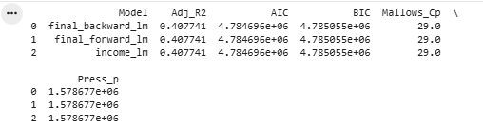
Hence, picking either of these models will be the correct answer. For the remainder of this project, we used our manually defined model: income_lm= 'lny ~ PWGTP + C(SEX) + C(RAC1P) + C(SCHL) + AGEP * WKHP + AGEP * C(SEX) + WKHP * C(SCHL)'

Model Fitting & Inference
The Global F-test produced F-value= 4.301e+04 and a p-value < 0.001.
Ho: All slope coefficients are equal to zero.
Ha: At least one coefficient is not zero.
𝛂= 0.05
Since p-value is less than 0.05, we reject the null hypothesis. There is strong statistical evidence at 𝛂= 0.05, that the model is significant overall.
To test the Extra Sum of Squares, we used the Type I (Sequential) Test.
Ho : Variable does not explain any additional variability.
Ha: Variables do explain additional variability.
𝛂= 0.05
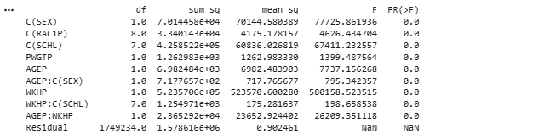
Result: There is enough evidence at 𝛂= 0.05 to reject the null hypothesis, each variable adds a statistically significant amount of explanatory power to the model.
Then, we set up a 95% CI and PI. For both Intervals, we set our variables to a Male, Black, Bachelor, aged 35 and, working 40 hour weeks.
Results for the CI: [51534.151356, 52575.21027], Results for the PI: [8103.083928, 334368.848683]

Checking Regression Assumptions (Diagnostics)
Diagnostic Plots: Residuals vs. Fitted values plot, Normal Q-Q plot.
The residuals vs fitted values plot was used to assess Linearity and the residuals appeared mostly scattered around the zero line with no strong curved pattern.
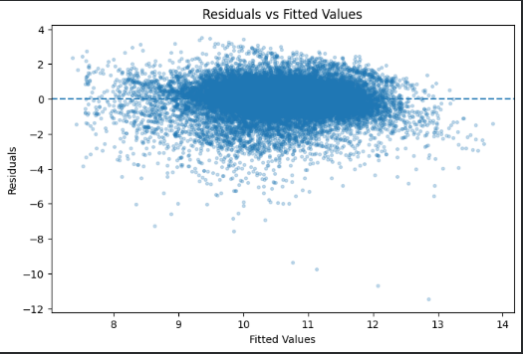
For independence we used Durbin Watson. The Durbin Watson statistic was 1.885. This would suggest that there is not strong autocorrelation among the residuals, so the independence assumption is satisfied.
When checking the Normality, we used the QQ plot and Shapiro Wilk Test. The Shapiro Wilks p-value is extremely small at 8.35 * 10^-45, which would mean that the residuals are not normal. As far as the QQ Plot we can also see data that correlates that statement, with the tail of the QQ plot going pretty steep downwards towards the X axis. Although, the QQ plot did show the residuals followed the reference line in the middle.
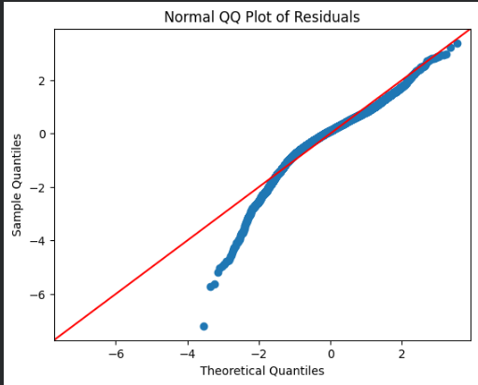
We used the Breusch Pagan test to check for Equal Variance, and that was not met. The Breusch Pagan P value is extremely small, outputting only zeros in the test. Since it is less than 0.05, we can reject constant variance and assume that equal variance was not met.
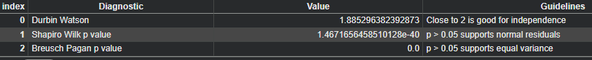
Multicollinearity: Checking VIF for the final model
The highest VIF was 217.65, which is WELL above the threshold of 10, so we can conclude that there is severe multicollinearity. Although the largest VIF values mostly came from categorical dummy variables and interaction terms such as C(RAC1P)[T.White], C(RAC1P)[T.Black], C(RAC1P)[T.Asian], C(RAC1P)[T.Other], C(RAC1P)[T.Two or more], and WKHP:C(SCHL)[T.Bachelor], AGEP:WKHP, AGEP:C(SEX)[T.Female] etc., which are interaction terms. This can be found in the Colab under the multicollinearity section, but we have attached a screenshot of the top 5 highest VIF.
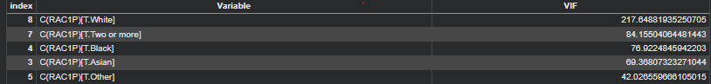
Influential Points: Check for extreme outliers or high-leverage points using Studentized residuals, Leverage values (hat matrix), and Cook's Distance.
When checking for high leverage points using Studentized residuals, we considered the potential outliers that were classified to be greater than 3 or -3, because their observed log-income values were much farther from the models predicted values. It works like a classification system, so if the model predicts the point very well, it's classified as a zero. If the point is somewhat far off from the prediction, it is classified as a 2. If the point is really far off from the prediction it is classified as a 3. This can go the other way too, the point could be below the predicted value hence the -3. This is checking whether some people have log income values much higher or lower than the model predicted using response variables of log income.
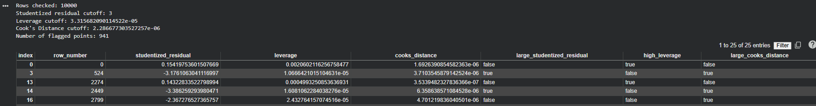
For the Leverage Values, we set a cutoff value of 2 * p/n, where p is the number of model coefficients including the intercept and n is the sample size. So the observations flagged as possible high leverage points, were leverage values greater than 2 * p/n. As you can see in the screenshot, any observation that met that criteria was marked true and false if not.
For Cooks Distance, we used the cutoff of 4/n, like we learned. So any observations flagged meant the cooks distance > 4/n. This was used to measure the overall influence of each observation on the fitted regression model by combining information from the residual size and leverage value. These values were flagged because removing them could affect the fitted model. Something to note is, because the dataset is pretty large, some observations could be flagged by the influence diagnostics because the cutoff values become very small when n is large.Although, the largest Cooks Distance values were still small in size, which would mean that no single observation appeared to really affect the fitted model. As you can also see in the screenshot above, we marked the cook's distance as true or false based on if it was large or not.

Remedial Measures.
Here we applied remedial measures for Multicollinearity, by changing the actual age into Age centered which is age - average age, and changing actually weekly work hours into work hours centered which is weekly work hours - average weekly work hours. Multicollinearity essentially means predictors are overlapping too much, and centering helps to reduce overlap. For example, AGEP * WKHP will be highly related to AGEP and WKHP. We chose to do this because dropping predictors like we learned would actually weaken the research. The model output below shows that this model explains about 40.8% of the variation in log income. The second screenshot shows VIF values after centering. Centering did help reduce multicollinearity in the continuous interaction terms but the highest VIF values are still really high. As far as the violations, there is concern for severe multicollinearity and this impacts the reliability of p values and confidence intervals because they may be unstable or inflated.
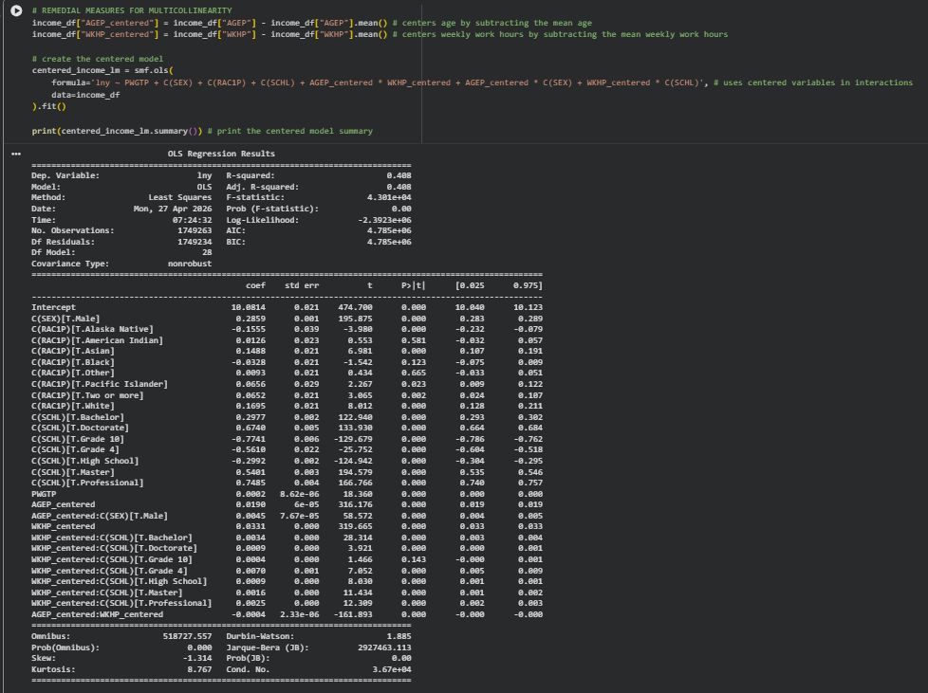
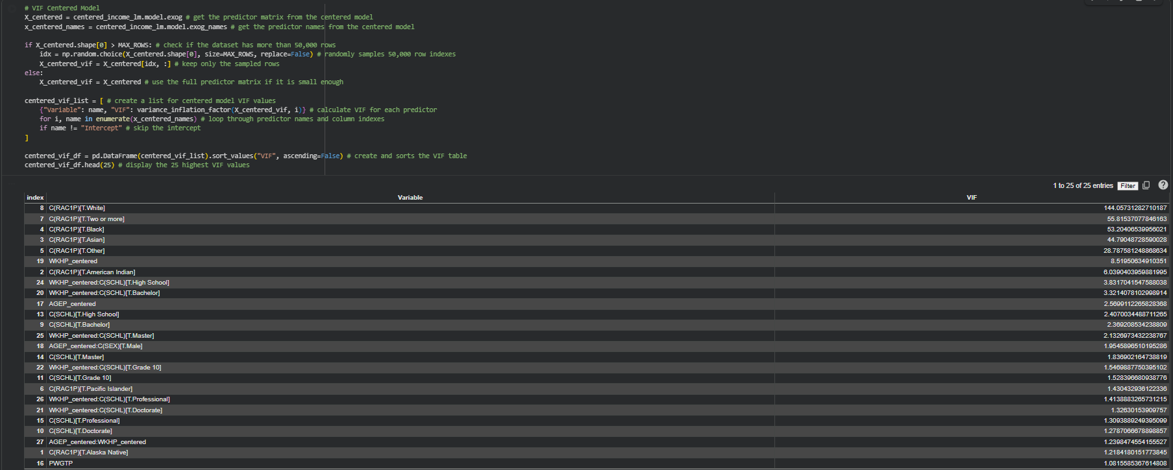
The HIGHEST VIF after centering AGEP and WKHP is 125.98 from C(RAC1P)[T.White]. Multicollinearity is definitely still present since this is well above the 10 threshold. Centering helped to reduce the VIF from 197 and within the interaction terms but still is strong among the dummy variables. However, this model can still provide useful overall predictive and explanatory information about income patterns.

Model Version | Highest VIF | Variable w/ highest VIF | Interpretation
Original LM | 217.65 | C(RAC1P)[T.White] | Multicollinearity is severe
Centered model | 125.98 | C(RAC1P)[T.White] | Reduced but still severe

I also want to mention the QQ plot and normality. It showed the residuals followed the normal line in the center but kind of deviated in the tail end of it, which would suggest that the residuals are not perfectly normal. We did not apply any extra remedial measures because the response variable was already log transformed: income_df= income_df.assign(lny= (np.log(income_df.PINCP))).

Results
Variable | Coefficient (b) | Std. Error | t-stat | p-value
Intercept | 7.7442 | 0.0219 | 353.7477 | 0.0
C(SEX)[T.Male] | 0.0546 | 0.0042 | 12.8574 | 0.0
C(RAC1P)[T.Alaska Native] | -0.1555 | 0.0391 | -3.9797 | 0.0001
C(RAC1P)[T.American Indian] | 0.0126 | 0.0227 | 0.5526 | 0.5805
C(RAC1P)[T.Asian] | 0.1488 | 0.0213 | 6.9814 | 0.0
C(RAC1P)[T.Black] | -0.0328 | 0.0213 | -1.5423 | 0.123
C(RAC1P)[T.Other] | 0.0093 | 0.0214 | 0.4337 | 0.6645
C(RAC1P)[T.Pacific Islander] | 0.0656 | 0.029 | 2.2671 | 0.0234
C(RAC1P)[T.Two or more] | 0.0652 | 0.0213 | 3.0654 | 0.0022
C(RAC1P)[T.White] | 0.1695 | 0.0211 | 8.0123 | 0.0
C(SCHL)[T.Bachelor] | 0.2093 | 0.0042 | 50.3606 | 0.0
C(SCHL)[T.Doctorate] | 0.6498 | 0.0088 | 73.6333 | 0.0
C(SCHL)[T.Grade 10] | -0.7851 | 0.0075 | -104.7611 | 0.0
C(SCHL)[T.Grade 4] | -0.7417 | 0.0264 | -28.1358 | 0.0
C(SCHL)[T.High School] | -0.3237 | 0.0039 | -83.2154 | 0.0
C(SCHL)[T.Master] | 0.4995 | 0.0048 | 105.1197 | 0.0
C(SCHL)[T.Professional] | 0.6837 | 0.0076 | 90.0816 | 0.0
PWGTP | 0.0002 | 0.0 | 18.3602 | 0.0
AGEP | 0.0287 | 0.0001 | 380.3421 | 0.0
AGEP:C(SEX)[T.Male] | 0.0045 | 0.0001 | 58.5718 | 0.0
WKHP | 0.0525 | 0.0002 | 316.2366 | 0.0
WKHP:C(SCHL)[T.Bachelor] | 0.0034 | 0.0001 | 28.3138 | 0.0
WKHP:C(SCHL)[T.Doctorate] | 0.0009 | 0.0002 | 3.9212 | 0.0001
WKHP:C(SCHL)[T.Grade 10] | 0.0004 | 0.0003 | 1.466 | 0.1427
WKHP:C(SCHL)[T.Grade 4] | 0.007 | 0.001 | 7.0519 | 0.0

For our quantitative variables:
index | Mean | Median | Std Dev | Range
PWGTP | 95.17 | 71.0 | 85.99 | 2299
AGEP | 51.89 | 53.0 | 19.05 | 81
WKHP | 27.06 | 40.0 | 20.4 | 99
PINCP | 72032.47 | 48000.0 | 91695.44 | 1944999
For our categorical variables:
Frequency table for SEX:
Count Percent (%)
Female 897809 51.32
Male 851454 48.68
Frequency table for RAC1P:
Count Percent (%)
White 1264557 72.29
Two or more 151083 8.64
Black 130136 7.44
Asian 117523 6.72
Other 67802 3.88
American Indian 13003 0.74
Pacific Islander 2302 0.13
AIAN tribes 2022 0.12
Alaska Native 835 0.05
Frequency table for SCHL:
Count Percent (%)
High School 576051 32.93
Bachelor 544217 31.11
Master 261334 14.94
Associate 221542 12.66
Professional 60416 3.45
Doctorate 46096 2.64
Grade 10 37324 2.13
Grade 4 2283 0.13

Final Regression Equation
ln(Y) = 7.7442+0.0546⋅Male−0.1555⋅AlaskaNative+0.0126⋅AmericanIndian+0.1488⋅Asian
−0.0328⋅Black+0.0093⋅Other+0.0656⋅PacificIslander+0.0652⋅TwoOrMore+0.1695⋅White
+0.2093⋅Bachelor+0.6498⋅Doctorate−0.7851⋅Grade10−0.7417⋅Grade4−0.3237⋅HighSchool
+0.4995⋅Master+0.6837⋅Professional+0.0002⋅PWGTP+0.0287⋅AGEP+0.0045⋅(AGEP×Male)
+0.0525⋅WKHP+0.0034⋅(WKHP×Bachelor)+0.0009⋅(WKHP×Doctorate)+0.0004⋅(WKHP×Grade10) +0.0070⋅(WKHP×Grade4)

Interpretation of Coefficients:
1. AGEP × Male (0.0045): The coefficient of 0.0045 indicates that the effect of age on income is higher for males than for females. Specifically, for males, each additional year of age increases log income by an additional 0.0045 compared to females. In percentage terms, this suggests that income grows faster with age for males, implying that the gender income gap widens over time.
2. WKHP × Bachelor (0.0034): The coefficient of 0.0034 indicates that the return to working additional hours is greater for individuals with a bachelor’s degree compared to the reference education group. Specifically, for individuals with a bachelor’s degree, each additional hour worked increases log income by an additional 0.0034 beyond the base effect of work hours. This suggests that more educated individuals benefit more from additional labor effort.
3. WKHP × Grade 4 (0.0070): The coefficient of 0.0070 indicates that the effect of working additional hours is higher for individuals with a Grade 4 education compared to the reference group. Specifically, each additional hour worked increases log income by an additional 0.0070 for this group. However, despite this higher marginal return to hours, individuals with low education levels still have substantially lower overall income due to the large negative main effect associated with low education.

Discussion
The results of the analysis largely support the initial hypothesis that individual income is influenced by a combination of personal characteristics and labor-related factors. The regression models consistently show that variables such as education, work hours, age, gender, and race play significant roles in explaining variation in income. Education being a main factor.
- The returns to working more hours are higher for individuals with greater educational attainment, meaning that more educated individuals benefit more from additional labor effort.
- The gender income gap increases with age, suggesting that differences in earnings between males and females widen over time.
- The effect of work hours varies with age, indicating that younger individuals may gain more from additional work hours than older individuals.
Limitations: OLS assumptions are not perfectly met, heteroskedasticity, omitted variable bias

Conclusion
The final model using log-transformed income performs well, explaining about 40% of the variation in income (R² ≈ 0.40). Given the complexity of income determination, this is a strong result. The use of a log transformation improves model stability and interpretability, allowing coefficients to be understood as approximate percentage changes. Including interaction terms further enhances the model by capturing how the effects of key variables differ across individuals. Income is not determined by a single factor but by a combination of education, labor effort, demographics, and their interactions. The model shows that improving human capital (education and skills) and understanding how different factors interact can lead to better economic outcomes and more informed decision-making. Overall, the model provides a reliable and meaningful framework for understanding income patterns, though results should be interpreted as associations rather than causal effects.

References
- M. H. Kutner et al (2005). Applied Linear Statistical Models, 5th edition
- United States Census Bureau. American Community Survey (ACS), U.S. Department of Commerce, https://www.census.gov/programs-surveys/acs
- https://online.stat.psu.edu/stat501/lesson/12/12.6

